**深 圳 大 学 实 验 报 告**

**课程名称：­ 随机信号处理**

**实验项目名称： 在实际信号处理中的自相关与互相关操作**

**学院： 电子与信息工程学院**

**专业： 电子信息工程**

**指导教师： 孙维泽**

**报告人： 陈应权 学号：2022280297**

**班级： 22文华班**

**实验时间： 2024年4月20日——2024年5月18日**

**实验报告提交时间： 2024年5月18日**

**教务处制**

Description of format:

* Use Times New Roman, 12 pt, single column, single line spacing.
* When inserting figures and tables, title of the figures and tables must be included.
* Do not change ‘1、Purposes of the experiment’ and ‘2、Design task and detail requirement’.

**1、Purposes of the experiment**

1. Use Matlab to calculate the autocorrelation of some functions, and use the result to solve some typical problems.
2. Analyze the results and give reasonable conclusions

**2、Design task and detail requirement**

See ‘Appendix 1 – Task and requirement for experimental report 2.doc’.

**3、The result and Analysis**

* **Part 1 - Basic 1: (10 points)**

Please provide your code, they must be runnable and output the figure in your report.

1. Plot the signal, and the autocorrelation $R_{X}\left(τ\right)$, and Cross-Correlation $R_{XN}(τ)$.

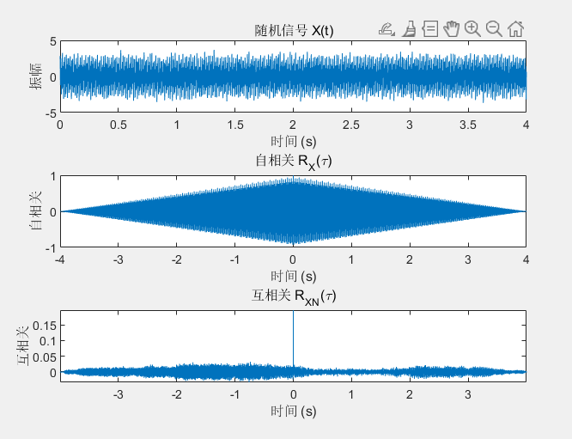

In the Basic 1 part of this experiment, our objective was to generate a signal composed of two sinusoids with different frequencies, superimposed with Gaussian white noise. We used MATLAB to simulate the signal and calculate its autocorrelation and cross-correlation. Here is the detailed analysis:

1. **Signal Generation**:
   1. We generated a signal 𝑋(𝑡)*X*(*t*) consisting of two

sinusoids: 𝑋1(𝑡)=cos(2𝜋𝑓1𝑡) and *X*2​(*t*)=2cos(2*πf*2​*t*), where 𝑓1=60 and 𝑓2=150.

* 1. To simulate the noise interference during the actual signal reception process, we added Gaussian white noise 𝑁(𝑡)*N*(*t*) to the signal with a mean of 0 and a variance of 𝜎2=0.1*σ*2=0.1.

1. **Autocorrelation Analysis**:
   1. The autocorrelation function 𝑅𝑋(𝜏)*RX*​(*τ*) shows the similarity between the signal and its time-shifted version at different time lags 𝜏*τ*.
   2. Since the signal 𝑋(𝑡)*X*(*t*) contains two sinusoids with different frequencies, we expect the autocorrelation function to exhibit peaks at the periods of these frequencies and their integer multiples.
   3. The peak positions in the autocorrelation function help us identify the periodic components in the signal, even in the presence of noise.
2. **Cross-correlation Analysis**:
   1. The cross-correlation function 𝑅𝑋𝑁(𝜏)*RXN*​(*τ*) is used to analyze the similarity between the signal 𝑋(𝑡)*X*(*t*) and the noise 𝑁(𝑡)*N*(*t*).
   2. Since Gaussian white noise is random, its cross-correlation function should theoretically be close to zero at non-zero lags, demonstrating the randomness of the noise.
3. **Experimental Results**:
   1. We plotted the time series graph of the signal 𝑋(𝑡)*X*(*t*), showing the sinusoidal waveform superimposed with noise.
   2. The autocorrelation plot displayed the main peaks of the signal, corresponding to the periods of the two sinusoids.
   3. The cross-correlation plot showed the noise component, with a peak at zero lag, followed by a rapid decay.
4. **Conclusion**:
   1. Autocorrelation is a powerful tool for analyzing and identifying periodic components in a signal, even in the presence of noise.
   2. Cross-correlation analysis helps to differentiate the deterministic components from the random noise components in a signal.
   3. This experiment successfully demonstrated how to perform signal processing and analysis using MATLAB, laying the foundation for further signal processing and system identification experiments.

* **Part 2 - Basic 2: (40 points)**

1. Write your parameter setting here, using a table.

Parameter table

|  |  |
| --- | --- |
| True frequence (Hz) | 100 |
| Sampling frequence(Hz) | 1000 |
| Sampling period(s) | 0.01 |
| phase | 0 |

1. Use the autocorrelation to estimate your signal frequency, and explain why it is possible to estimate the signal frequency through autocorrelation. (Hint: write some theory/equations here, together with description or explanation. Equations without description or explanation are not acceptable because no one can understand anything with only equations)

Autocorrelation is a mathematical operation used to find repeating patterns within a signal by correlating it with a delayed version of itself. In the context of signal processing, autocorrelation can be utilized to estimate the frequency of a periodic signal.

The autocorrelation function $R\left(τ\right)$ of a signal $x\left(t\right)$ is defined as:

$$R\left(τ\right)=\int_{-∞}^{∞}{x}\left(t\right)x\left(t-τ\right)dt$$

Where $τ$ represents the time delay or lag between the original signal and its delayed version.

For a periodic signal with frequency $f$,the autocorrelation function exhibits peaks at multiples of the period $T=\frac{1}{f}.$ This is because when the delayed version of the signal aligns perfectly with the original signal, the correlation is maximized. Therefore, the periodicity of the signal manifests as peaks in the autocorrelation function at intervals corresponding to the signal’s period. By analyzing the autocorrelation function, we can observe these peaks and determine the time lag at which they occur. From the time lag, we can then calculate the corresponding frequency of the signal using the relationship:

$$f=\frac{1}{τ}$$

Therefore, by estimating the autocorrelation function and identifying the peaks, we can infer the frequency of the underlying periodic signal. This approach is particularly useful when the signal is noisy or when its frequency content is not immediately apparent in the time- domain representation. Autocorrelation provides a robust method for extracting periodicity and estimating frequency even in such scenarios.

1. For $σ^{2}$ =0.5, 1, 5 (you can try more), plot the figure of Autocorrelation for one run.

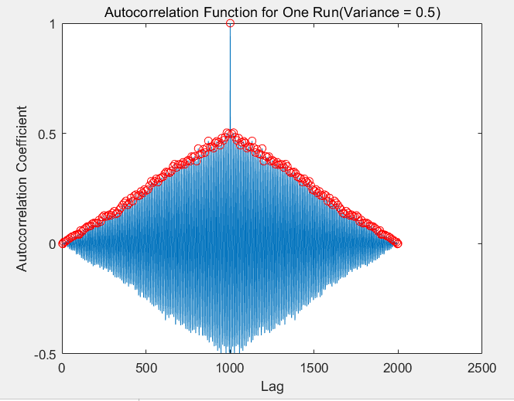

Estimated frequency: 99.19 Hz, Error: 0.81 Hz when variance is 0.50

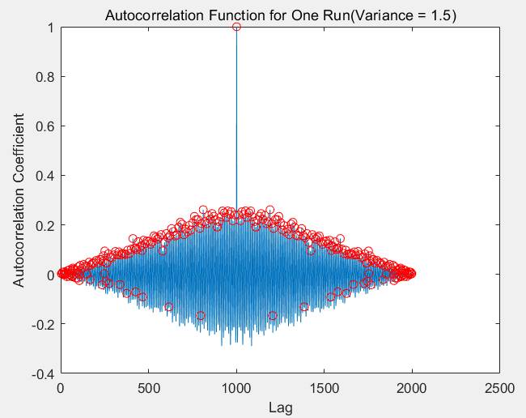

Estimated frequency: 112.30 Hz, Error: 12.30 Hz when variance is 1.50

It can be observed that when the noise variance is larger, the noise signal will become stronger, resulting in a greater impact on the original sinusoidal signal, resulting in a wrong point in finding the autocorrelation peak point, which will lead to a certain error.

1. Test the accuracy of **your estimation of signal frequency** using autocorrelation for **100 independent runs**, show the results using table(s) or figure(s), and give analysis. (Hint: to get a result of **100 independent runs**, you should write a ‘for’ loop)

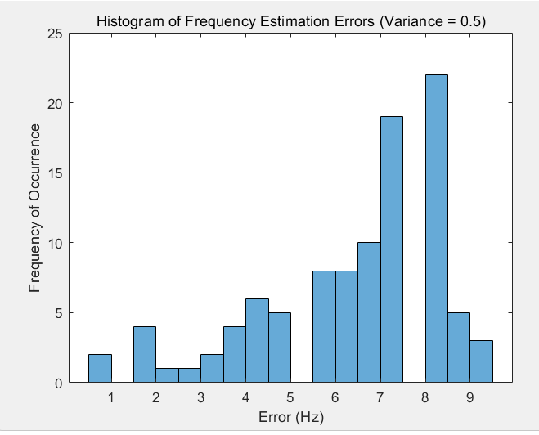

Average frequency estimation error over 100 iterations: 6.57 Hz when variance is 0.50

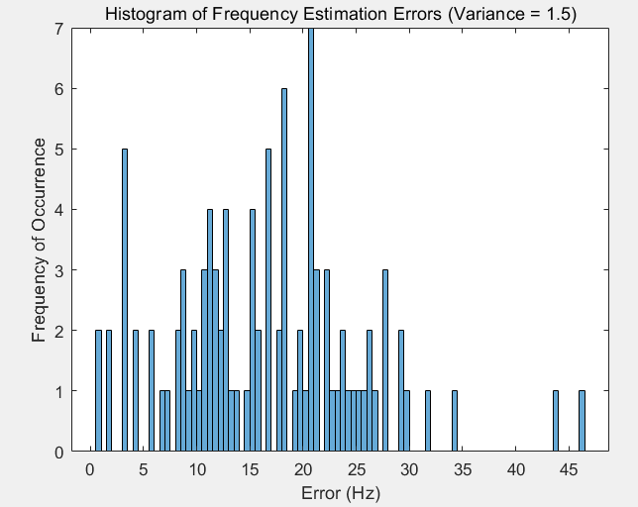

Average frequency estimation error over 100 iterations: 16.44 Hz when variance is 1.50

* **Part 3 – Advance 1:**

1. Explain your method (add the signals from the 4 microphones with correctly estimated lags) with necessary texts, equations, and/or flowchart.
2. Show the figures under 3 SNR cases (SNR = 30,10,-10dB).
3. Your analysis.

* **Part 4 – Advance 2:**

1. Please list the corresponding DOAs for all lags from -11 to +11 in one table. (there are totally 23 numbers)
2. Show the flow chart of your program, the estimation result (correct detection percentage or other indicators) of the DOA versus SNR(dB), and your analysis.
3. Show the flow chart of your program, the estimation result (correct detection percentage or other indicators) of the DOA versus SNR(dB), and your analysis.

* **Part 5: Extra**

Is there any method to get better estimation? Please try it and give your result, **including flow chart of your program, explanation of your method, the estimation result (correct detection percentage or other indicators) of the DOA versus SNR(dB), and your analysis.**

|  |
| --- |
| 指导教师批阅意见：  成绩评定：  指导教师签字：  年 月 日 |
| 备注： |

注：1、报告内的项目或内容设置，可根据实际情况加以调整和补充。

2、教师批改学生实验报告时间应在学生提交实验报告时间后10日内。